Autonomous Robots
CSE 4360 – 001
12/05/2024
Due Date : Dec 11 , 2024

Project 3

Group Members :
Jason Cabrejos
Don Bui
Aryan Mainkar
The Design :
Robot’s design :
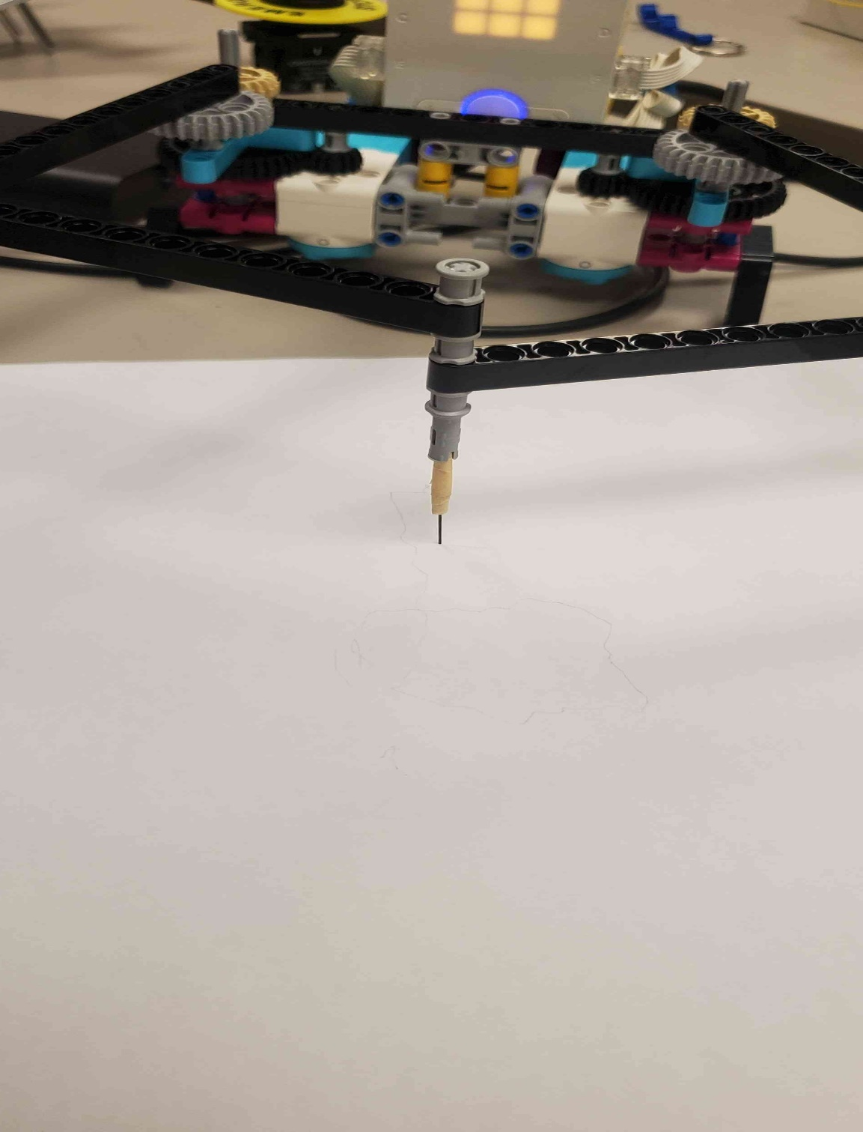

Design choices :
Picasso.py :
- Picasso code is made to operate a robotic arm with several motors and uses inverse kinematics to calculate joint angles for accurate placement.
- With the Picasso class encompassing parameters like arm link lengths, gear ratios, and the robot's starting location, the code employs a class-based structure.
- The fundamental functionality is supplied by the inverse kinematics approach, which determines potential configurations by computing joint angles using trigonometric equations such as the cosine rule. For seamless transitions between designated target positions, the InterpolateMoves function creates intermediate points.
- By interpolating pathways in tiny stages, it guarantees fine-grained control. By instructing motors to perform estimated movements and guaranteeing synchronisation through PID control loops written in helper functions (TurnMotorForAngle and TurnMotorsForAngle), the plot approach combines these aspects.
- For jobs requiring delicate control, such as drawing or object manipulation, articulated robotic arms can be used because of the design's emphasis on accuracy and versatility for various motion trajectories.

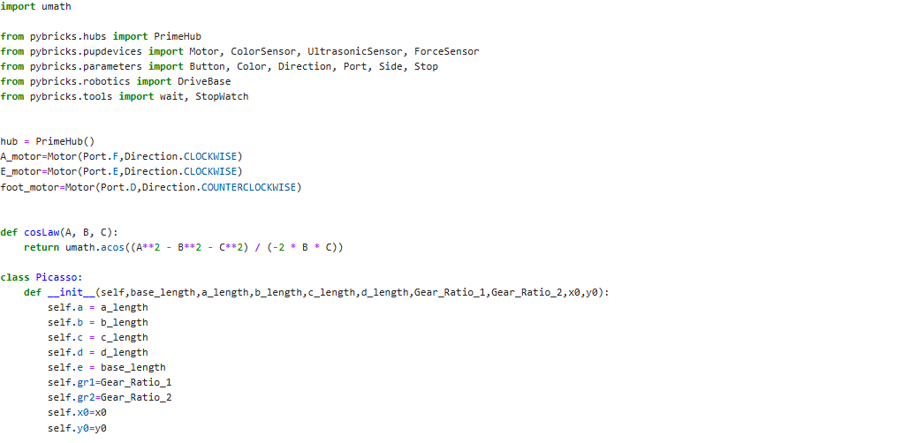
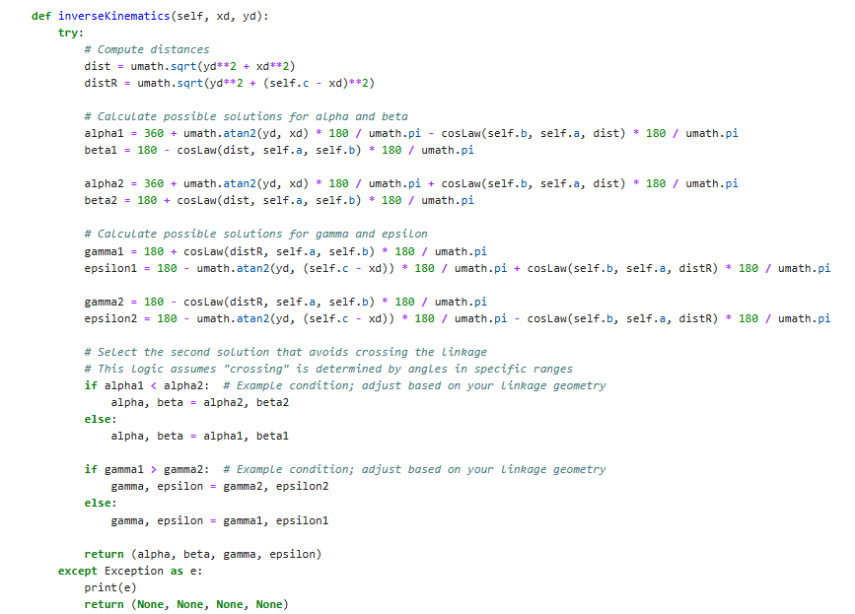
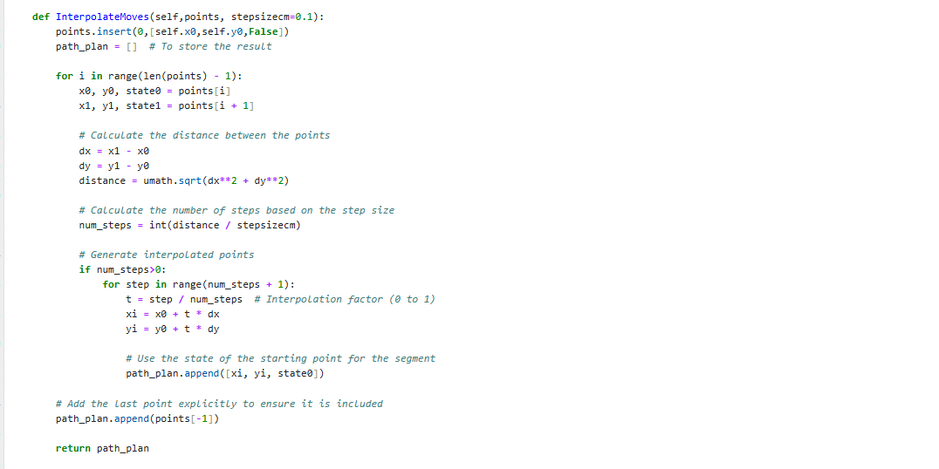
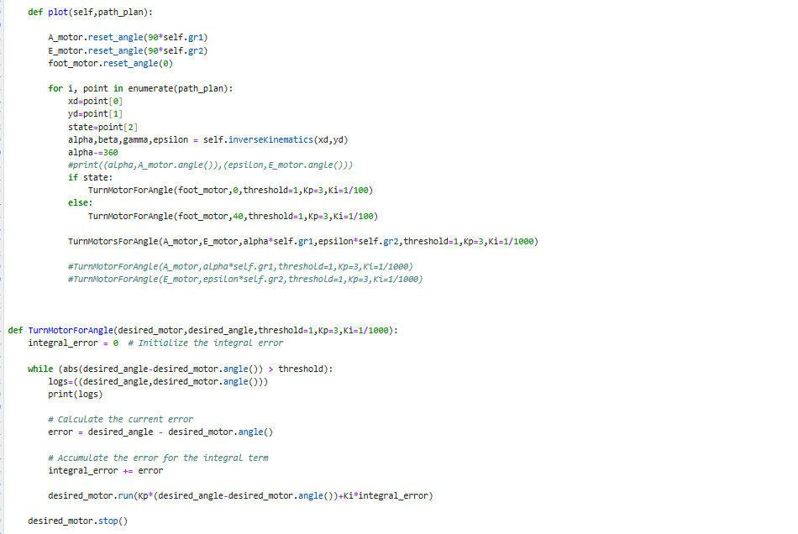
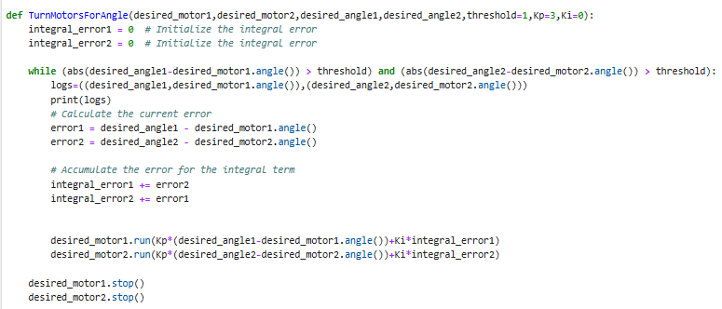

CalibrationTest.py :
- Code B focuses on controlling a two-wheeled robot with motors for simple motions like turning and straight drive.
- It offers several locomotion techniques, such as MoveStraightForDistance, which uses proportional control to guarantee precision and determines the motor angles needed to travel a given distance based on the wheel radius.
- Similar to this, TurnForAngle uses a closed-loop control system to execute turning capability by precisely adjusting the heading using the onboard IMU (inertial measuring unit).
- For less complex control, simpler legacy techniques like MoveStraightForAngleLegacy and TurnForAngleLegacy are offered; these methods just use motor encoders and do not receive feedback from the IMU.
- The code is appropriate for wheeled robots doing navigation tasks like exploration or maze-solving since the entire design strives for robust and efficient movement with proportional control for error correction.
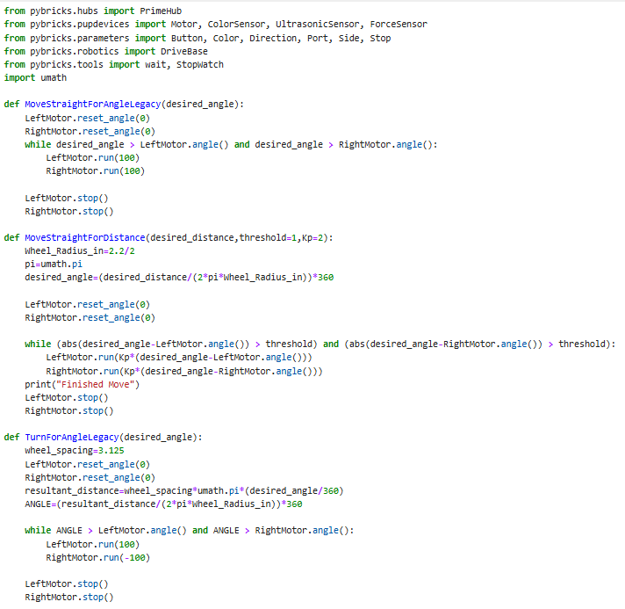
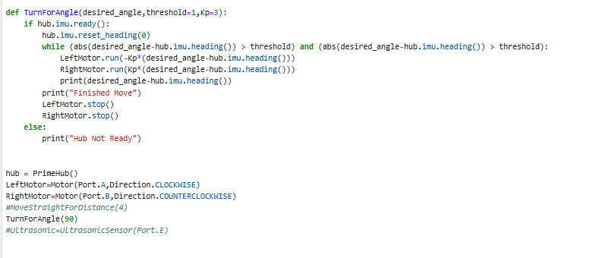

Navigation Strategy :
- By creating intermediate waypoints, the InterpolateMoves function executes a navigation technique that guarantees accurate and seamless movement between designated points.
- The method determines the interpolated positions along the straight-line trajectory between each pair of subsequent points by segmenting the path into smaller steps according to a specified step size (stepsizecm).
- As a result, the robot can follow a consistent and continuous course, keeping each segment's starting point state (such as tool activation).
- The method works especially well for fine-grained control in applications that need precise transitions, like path-following mobile robots or robotic arms.
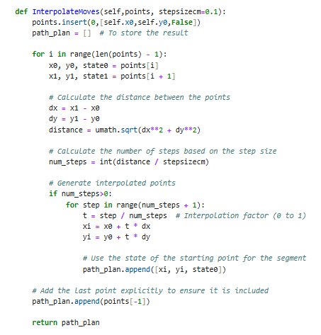
Calibration Strategy :
- The provided code demonstrates a calibration strategy aimed at ensuring precise and consistent movements for a robot using its motors and sensors.
- Motor angle sensors are reset at the beginning of movement functions (e.g., MoveStraightForAngleLegacy, TurnForAngle) to establish a reference point for measuring rotations or distances.
- Proportional control (Kp) is used in movement functions like MoveStraightForDistance and TurnForAngle to minimize errors by dynamically adjusting motor speeds based on the difference between desired and actual positions or angles.
- Additionally, the IMU (Inertial Measurement Unit) is utilized for precise angular calibration in turning, with its heading reset to zero before initiating a turn. These steps ensure reliable navigation and minimize drift during operation.
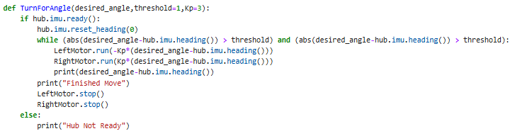
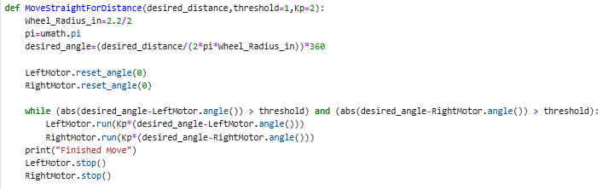

Python Code :

